System Design Document
Quick Grad Planner
Customer: Dr. John Callahan

South Pole Tigers

Payal Aggarwal
Heather Long
Christopher Stark
Emmanuel Tebong
Patrick Trinkle

October 30, 2005

Quick Grad Planner by South Pole Tigers
System Design Document Template

Table of Contents

Page

1. Introduction 2

  - Purpose of This Document 2
  - References 2

2. System Architecture 3

2.1 Architectural Design 3
2.2 Decomposition Description 4

3. Component Design 7

4. Global Data 12

5. Persistent Data Design 12

5.1 Database Descriptions 12
5.2 File Descriptions 14

6. Runtime Environment 15

7. Requirements Matrix 16

Appendix A – Peer Review Sign-off 18

Appendix B – Agreement Between Customer and Contractor 19

1. Introduction

1.1 Purpose of This Document

The purpose of this document is to give an overview of the design for the Quick Grad Planner. This document gives an overview of the software’s system architecture, as well as a description of the decomposition of the system into components. A description of each function to be used is listed in the component design. All pertinent global data and persistent data is also included in this document. A description of the runtime environment is given, with a description of the database and operating system that will be used. A requirements matrix is included, showing which system components satisfy each of the functional requirements from the SRS. The intended readers of this document are South Pole Tigers, the software development team, and the client.

1.2 References

The following is a list of references used when compiling this document.

Quick Grad Planner System Requirements Specification, South Pole Tigers, October 11, 2005.

Quick Grad Planner User Interface Design Document, South Pole Tigers, October 11, 2005.

SDD Template, Susan Mitchell http://www.csee.umbc.edu/courses/undergraduate/345/fall05/mitchell/Templates/sddTemplate.doc

2. System Architecture

2.1 Architectural Design

Quick Grad Planner is designed to assist a student, and potentially his or her academic advisor, in planning and managing the classes they will take each semester. Only one student will be managed, and this student’s records can be managed in the fashion of adding, removing, and modifying courses. Upon completing the graduation plan, in part or in full, it may be viewed or printed.

The system is broken down into multiple main components, of which will be mainly a hybrid of object-oriented and procedural code. On the highest level, the User Interface will be a versatile and simple system for communicating with the student. Then, the Main Driver will determine the actions to be done to the graduation plan, which then will be broken down into the New Plan sub-systems, Manage Plan Sub-system, Print Plan Sub-system, and View Plan Sub-system. The New Plan Sub-system will handle all of the operations dealing with initial creation of a graduation plan. The Manage Plan Sub-system will control all semesters and their courses, and all operations pertaining to the changing, removing, or inputting of semester data and course selection. The Print Plan Sub-system will handle the printing of the data in the graduation plan, either completed in full or in part. Finally, the View Plan Sub-system provides a means to view the plan so as to gain a view of the entire plan quickly and easily. See Figure 1 below.
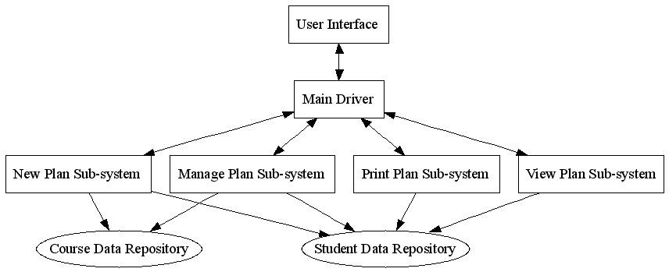
Figure 1: System Architecture Diagram

2.2 Decomposition Description

This section is a description of the classes and functions that make up the subsystems of the Quick Grad Planner as depicted in Figure 1.1. Figure 2.2.1 depicts in further detail the functional decomposition. Figure 2.2.2 is the class diagram for the Quick Grad Planner.

The Main Driver of the Quick Grad Planner will either create a new student record via the function new, or retrieve a student record via the function getStudentRecord. The student can modify, view, or print their Graduation Plan. Modify functionality is comprised of adding, modifying, and deleting semesters. When modifying a semester the student can add, delete, or modify courses. Modifying a course consists of changing the grade received for that course or changing the comment to that course. View functionality is comprised of viewing a range of semesters or either the courses requirements remaining for graduation or the specific information about a course. The Quick Grad Planner can either print a range of semesters specified by the student or print the entire plan.

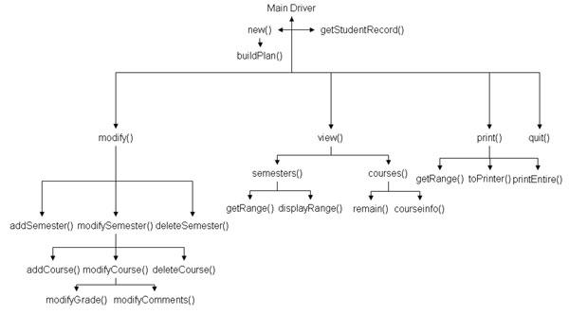
Figure 2.2.1 Functional Decomposition Diagram

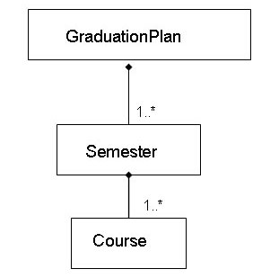
Figure 2.2.2 Quick Grad Planner Class Diagram

The New Plan Subsystem requests a blank GraduationPlan and sends this to the Main Driver to retrieve the User Data so as to build up Student Data. The Manage Plan Subsystem interfaces with the current GraduationPlan and Student as defined in the Student Data Repository. The View Plan Subsystem requests Semesters and Courses from the GraduationPlan. It requests Semester when displaying stored semester information, and it requests courses to display the remaining requirements. The Print Plan Subsystem receives a range of Semesters from the Main Driver and then requests them from the GraduationPlan. A GraduationPlan instance is composed of 1 or more Semester instances. A Semester instance is composed of 1 or more Course instances.

Course Class – this class contains all data pertaining to a course, to include but not limited to its prerequisites, title, and description.

Course
int number
string title
string designator
string comments
char grade
vector<Course> prereqs or vector<int>?
+getNumber(): int
+getTitle(): string
+getDesg(): string
+getComments(): string
+inputnewGrade(): char
+inputComments(…): void

Semester Class – this class contains the Courses as Student has taken together in an academic semester. Semesters have a designator which is FL for Fall, WI for Winter, SP for Spring, and SU for Summer.

Semester
vector<Course> courses
string designator
int year
+viewCourse(): Course
+deleteCourse(): String
+addCourse(): String

GraduationPlan Class – this class contains all the Semesters a Student entered into the system as well as a Semester designated: startingSemester; indicating where to begin data range. The GraduationPlan Class also contains Student Data such as the student’s major.

GraduationPlan
string studentName
Semester startingSemester
string major
vector<Semester> plan
+printGradPlan(): void
+viewGradPlan(): void
+modifyGradPlan(): void
-addsemester(): void
-deletesemester(): void

3. Component Design

The following gives descriptions of the methods outlined in section 2.2 of this document. Descriptions are given for the method’s main purpose and its parameters, as well as its return values, and any pre-conditions and post-conditions. Methods are grouped by their class. Function descriptions are listed below the methods.

Course Class

/**************************************************************
* Function: getNumber *
* Purpose: Return the course number *
* Parameters: void *
* Return value: int *
* Pre-condition: None *
* Post-condition: Course number is returned *
**************************************************************/

/**************************************************************
* Function: getTitle *
* Purpose: Return the course’s title *
* Parameters: void *
* Return value: string *
* Pre-condition: None *
* Post-condition: Course title is returned *
**************************************************************/

/**************************************************************
* Function: getDesg *
* Purpose: Return the course designator (eg CMSC) *
* Parameters: void *
* Return value: string *
* Pre-condition: None *
* Post-condition: Course designator is returned *
**************************************************************/

/**************************************************************
* Function: getComments *
* Purpose: Return any comments for the course *
* Parameters: void *
* Return value: string *
* Pre-condition: None *
* Post-condition: Course’s comments are returned *
**************************************************************/

/**************************************************************
* Function: inputnewGrade *
* Purpose: Input a new grade for the given course *
* Parameters: char newGrade *
* Return value: char *
* Pre-condition: Grade must be A, B, C, D, F, P, or I *
* Post-condition: Grade is changed, and old grade is returned*
**************************************************************/

/**************************************************************
* Function: inputComments *
* Purpose: Input comments for the course *
* Parameters: string newComments *
* Return value: void *
* Pre-condition: Must have a string of comments to put in *
* Post-condition: Comments are created for course *
**************************************************************/

Semester Class

/**************************************************************
* Function: viewCourse *
* Purpose: Allows user to view the information in a *
* course *
* Parameters: int id *
* Return value: Course *
* Pre-condition: Course id must be valid *
* Post-condition: A Course is returned *
**************************************************************/

/**************************************************************
* Function: deleteCourse *
* Purpose: deletes a course in the semester *
* Parameters: int id *
* Return value: string *
* Pre-condition: Course id must be valid *
* Post-condition: Course name is returned *
**************************************************************/

/**************************************************************
* Function: addCourse *
* Purpose: Add a course to the semester *
* Parameters: Course *
* Return value: string *
* Pre-condition: Must be a valid course to be inserted *
* Post-condition: Course name is returned *
**************************************************************/

Graduation Class

/**************************************************************
* Function: printGradPlan *
* Purpose: Prints the graduation plan to printer *
* Parameters: void *
* Return value: void *
* Pre-condition: Must have a valid plan *
* Post-condition: Graduation plan is printed *
**************************************************************/

/**************************************************************
* Function: viewGradPlan *
* Purpose: Shows the graduation plan on the screen *
* Parameters: void *
* Return value: void *
* Pre-condition: Must be a valid graduation plan *
* Post-condition: Graduation plan shows on the screen *
**************************************************************/

/**************************************************************
* Function: modifyGradPlan *
* Purpose: Modifies the graduation plan *
* Parameters: Semester *
* Return value: void *
* Pre-condition: Must be a valid semester *
* Post-condition: Graduation Plan is modified *
**************************************************************/

/**************************************************************
* Function: addsemester *
* Purpose: Adds a semester to the graduation plan *
* Parameters: void *
* Return value: void *
* Pre-condition: Must be a valid semester *
* Post-condition: A semester is added to the graduation plan *
**************************************************************/

/**************************************************************
* Function: deletesemester *
* Purpose: Deletes a semester in the graduation plan *
* Parameters: void *
* Return value: void *
* Pre-condition: Must be a valid semester *
* Post-condition: A semester is deleted from the graduation *
* plan *
**************************************************************/

Functions

/**************************************************************
* Function: displayMenu() *
* Purpose: displays main menu *
* Parameters: void *
* Return value: void *
* Pre-condition: None *
* Post-condition: Main Menu displayed *
**************************************************************/

/**************************************************************
* Function: newStudent() *
* Purpose: displays menu choices if first entering app *
* Parameters: void *
* Return value: void *
* Pre-condition: user chose New from main menu *
* Post-condition: New Student menu is displayed *
**************************************************************/

/**************************************************************
* Function: modify() *
* Purpose: displays menu to modify grad plan *
* Parameters: void *
* Return value: void *
* Pre-condition: user chose Modify from main menu *
* Post-condition: Modify menu displayed *
**************************************************************/

/**************************************************************
* Function: addSemester() *
* Purpose: add semester to users’ grad plan *
* Parameters: void *
* Return value: void *
* Pre-condition: user chose to Add Semester from modify *
* menu *
* Post-condition: Course title is returned *
**************************************************************/

/**************************************************************
* Function: modifySemster() *
* Purpose: to modify a semester (add/delete/modify *
* course) *
* Parameters: void *
* Return value: void *
* Pre-condition: user chose to modify semester from *
* modify menu *
* Post-condition: Course title is returned *
**************************************************************/

/**************************************************************
* Function: addCourse() *
* Purpose: to add a course to users’ semester *
* Parameters: void *
* Return value: void *
* Pre-condition: user chose to add a course to semester in *
* Modify semester menu *
* Post-condition: Course title is returned *
**************************************************************/

/**************************************************************
* Function: deleteCourse() *
* Purpose: delete a course from user’s semester *
* Parameters: void *
* Return value: void *
* Pre-condition: user chose to delete a course from the *
* modify semester menu *
* Post-condition: Course title is returned *
**************************************************************/

/**************************************************************
* Function: view() *
* Purpose: view users’ grad plan *
* Parameters: void *
* Return value: void *
* Pre-condition: user chose to view from main menu *
* Post-condition: view menu is displayed *
**************************************************************/

/**************************************************************
* Function: print() *
* Purpose: print users’ plan *
* Parameters: void *
* Return value: void *
* Pre-condition: user chose to print from main menu *
* Post-condition: print menu is displayed *
**************************************************************/

4. Global Data
The Quick Grad Planner does not use any global variables.
5. Persistent Data Design
5.1 Database Descriptions
The Quick Grad Planner uses a database to manage the user’s semesters and courses. See Figure 3 below for the diagram representing this relationship. There will be two main tables, one for semesters and the other for courses.
Semester Table: This table will contain a list of all the semesters. The semesters will range from the student’s first semester to the student’s last semester taken. This table will consist of two columns:
<name> <year>
Where name is a string and is limited to being ‘Fall’, ‘Spring’, ‘Summer’, or ‘Winter’, and year is an integer that must be later than 1900.
Course Table: This table will contain a list of all courses offered by the CMSC, CS, IS, and CMPE departments. It will also contain a list of all accepted GFR courses for these majors. This table will consist of four columns:
<name> <number of credits> <Grade> <year taken>
Where the name is a string, example ‘CMSC345’
Number of credits an integer between 1 and 5,
Grade will be a char, example ‘A’
Year taken will be an integer greater than 1900
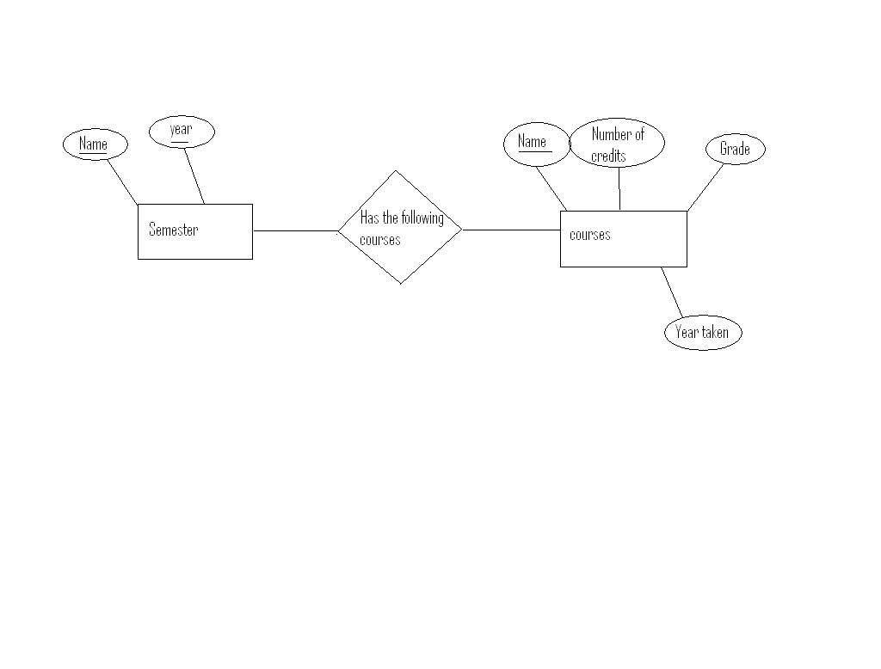
Figure 3. Database schema diagram

5.2 File Descriptions
No files are being used for this system.

6. Run-Time environment

The following is a description of the environment that is required to run the Research Development Tool. The environment description is grouped into two categories: hardware and software requirements.

Software Requirements:
-Windows 95 operating system or higher
-Compiled using g++
- Oracle 8i

Minimum Hardware Requirements:
-PC with 100 MHz Pentium/Celeron family processor
-16 MB of RAM
-5 MB of available hard disk space for the program code; 5 MB of available hard disk space for the database; 500 KB of available hard disk space for each student’s entry

7. Requirements Matrix

The purpose of the matrix below is to show the relationship between the classes and methods in the Quick Grad Planner and the use case specifications described in the System Requirements Specification. Each line in the matrix lists the use case specification and which methods and classes in the system correspond to this use case specification.

Use Case  # | Use Case Name | Classes | Method(s) | Function(s)
1  1.1  1.2  1.3  1.4 | Manage Graduation Plan  - Modify Plan Data  - New Graduation Plan  - View Plan Data  - Print Plan Data | GraduationPlan  GraduationPlan  GraduationPlan  GraduationPlan | modifyGradPlan()  viewGradPlan()  printGradPlan() | displayMenu()
2  2.1  2.2 | Modify Plan Data  - Add New Semester  - Modify Semester Data | GraduationPlan  Semester  Semester  Semester  Semester | addSemester()  viewCourse()  deleteCourse()  addCourse()  getYear() | newStudent()
3  3.1  3.2  3.3  3.4 | Modify Semester Data  - Add a Course  - Remove a Course  - Modify a Course  - Modify Plan Data | Semester  Semester  Semester  GraduationPlan | addCourse()  deleteCourse()  viewCourse()  getYear() | modifySemester()
4  4.1 | Remove a Course  a) Remove a Course | Semester | deleteCourse() | deleteCourse()
5  5.1  5.2 | Modify a Course  - Manage Graduation Plan  - Modify Semester Data | GraduationPlan  Semester  Semester  Semester  Semester | modifyGradPlan()  viewCourse()  deleteCourse()  addCourse()  getYear() | modifyCourse()  addCourse()  deleteCourse()
6  6.1 | New Graduation Plan  - New Plan | GraduationPlan |  | newStudent()
7  7.1  7.2 | View Plan Data  - View Semester Data  - View Remaining Graduation Requirements | Semester  GraduationPlan | viewCourse()  viewGradPlan() | View()
8  8.1 | View Semester Data  - View Course Data | Course  Course  Course | getTitle()  getDesg()  getComments() | view()
9  9.1  9.2 | View Course Data  - Manage Graduation Plan  - View Semester Data | GraduationPlan  GraduationPlan | getSemester() | view()
10  10.1  10.2 | View Remaining Graduation Requirements  - Manage Graduation Plan  - View Plan Data | GraduationPlan  GraduationPlan | viewGradPlan() | view()
11  11.1  11.2 | Print Graduation Data  - Print Entire Plan  - Print Parts of Plan | GraduationPlan  GraduationPlan | printGradPlan()  printGradplan() | print()
12 | Print Entire Plan  - Manage Graduation Plan  - Print Graduation Plan | GraduationPlan  GraduationPlan | printGradPlan() | print()
13 | Print Parts of Plan  - Manage Graduation Plan  - Print Graduation Plan Data | GraduationPlan  GraduationPlan | printGradPlan() | print()
Appendix A – Peer Review Sign-off

This is to denote and confirm that all members of the Quick Grad Planner team have seen and approved this design document, that it meets their standards of excellence and conveys the information that was agreed upon and will be done in the project. We the undersigned agree and confirm that the document above is our own work and approve of its contents with any additional comments to be noted upon signing. DATE
______________________________________________________ ______
______________________________________________________

______________________________________________________ ______
______________________________________________________

______________________________________________________ ______
______________________________________________________

______________________________________________________ ______
______________________________________________________

______________________________________________________ ______
______________________________________________________
Team Member Comments:
Appendix B – Agreement between Customer and Contractor
This is to denote and confirm that all members of the Quick Grad Planner team have met with our customer, Dr. Callahan, and both have approved the design document for the Quick Grad Planner project. It meets our standards of excellence and conveys the information that was agreed upon and will be done in the project. We the undersigned agree and confirm that the document above is our own work and approve of its contents, with any additional comments to be noted upon signing. DATE
______________________________________________________ ______
______________________________________________________

______________________________________________________ ______
______________________________________________________

______________________________________________________ ______
______________________________________________________

______________________________________________________ ______
______________________________________________________

______________________________________________________ ______
______________________________________________________

______________________________________________________ ______
______________________________________________________

Customer Comments:

